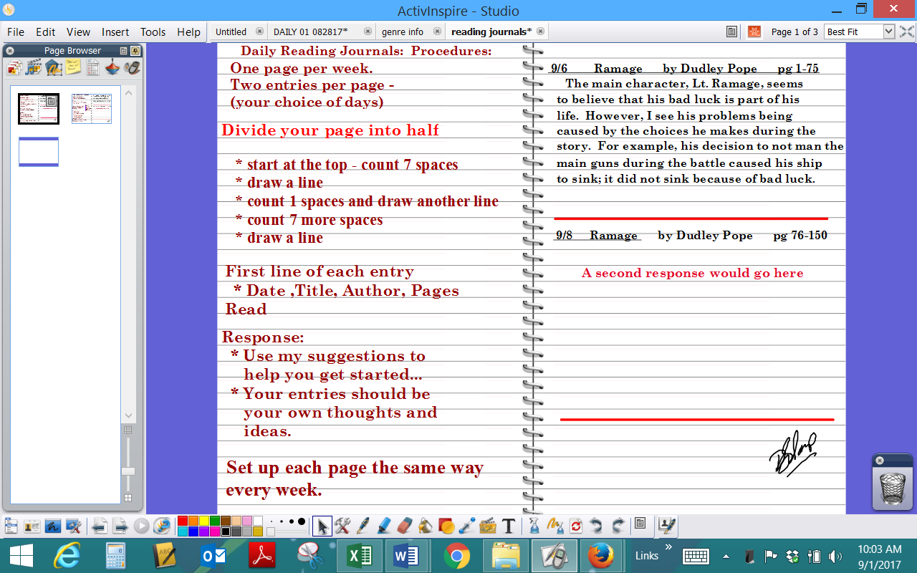
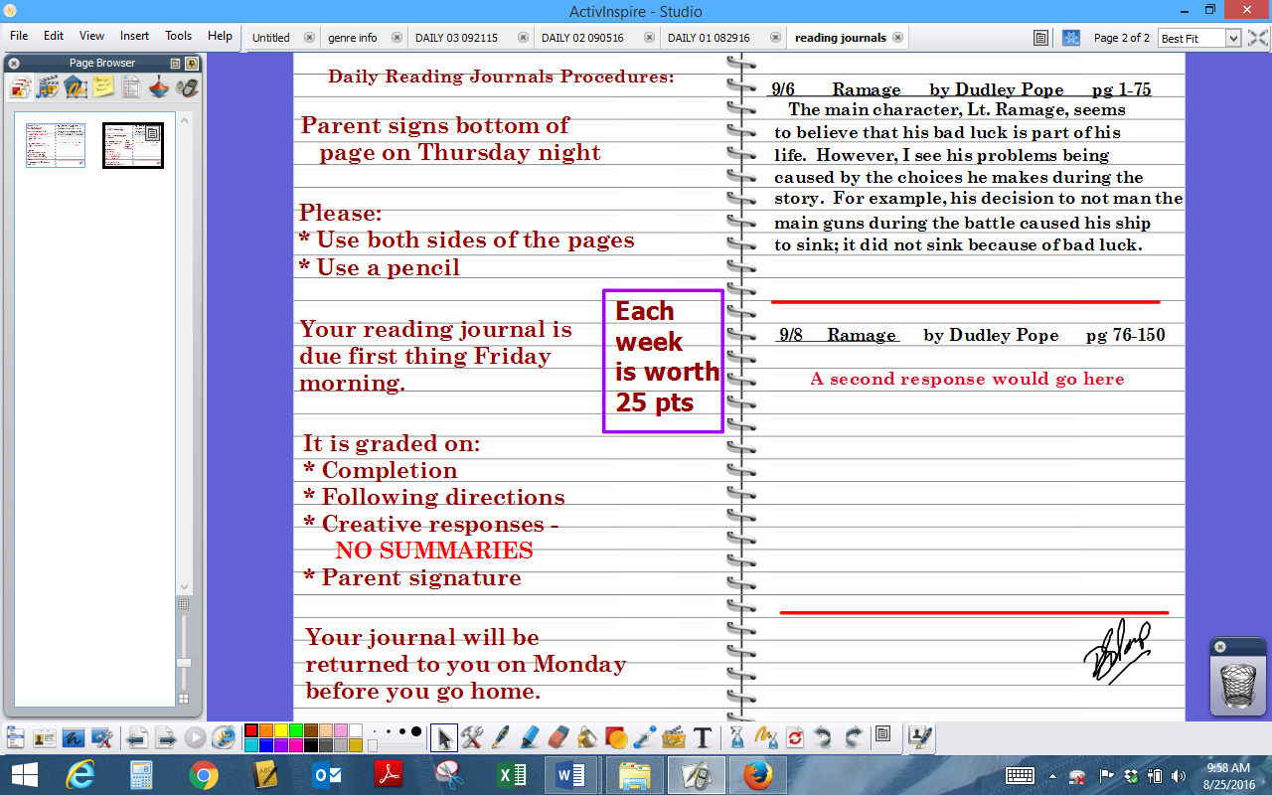

RESPONSE CHOICES: Use these as your starter ideas, then create an entry that discusses your choice.

DO NOT WRITE A SUMMARY OF WHAT YOU HAVE READ. I am looking for connections to the story. If I want a summary, I’ll just go read the book myself!

Each entry should be 4-5 well-written, detailed sentences, and MUST include evidence from the book to support your comment(s).

1. I was surprised when…because…

2. I can’t believe…because…

3. I wonder why…because…

4. I really didn’t understand…because…

5. This scene (short description) reminds me of a similar scene in (book title) because…

6. (Character) is OR is not like me because… [give at least two comparisons].

7. The character I most admire is (name) because…

8. This scene (short description) reminds me of a similar situation that happened to me (describe AND compare it to the scene).

9. I felt (happy…sad…angry…worried…etc) when….because…(Choose ONE emotion, and discuss your feelings.)

10. The part where (short description) happened is realistic/not realistic because…

11. This event (short description) is important to the plot because…

12. I believe the theme or central meaning of the book is…because…

13. Describe a problem that a character is facing then explain how YOU would solve it.

14. Tell me something you learned from today’s reading, and why it is important.

15. Describe and draw a symbol from the story and explain why it is important.

16. Describe the main setting, and explain why the author chose it for this story.

