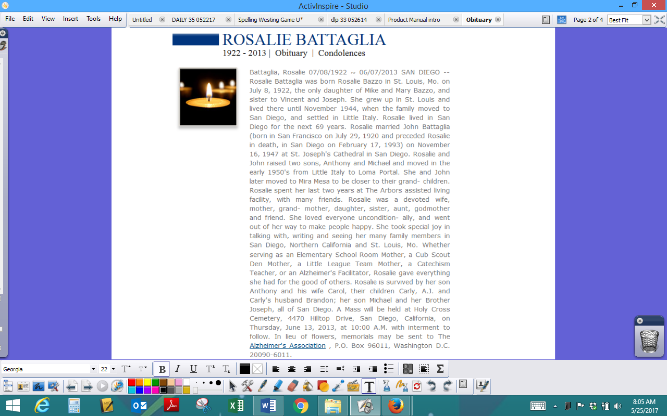
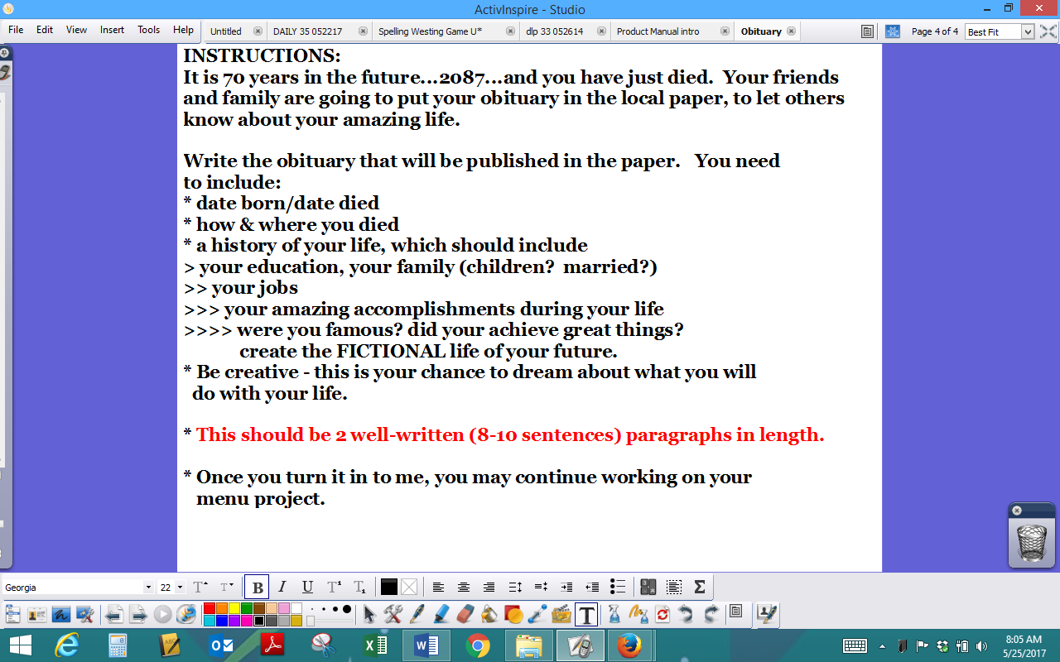

"Leslie Ray 'Popeye' Charping was born in Galveston on November 20, 1942 and passed away January 30, 2017, which was 29 years longer than expected and much longer than he deserved."
"At a young age, Leslie quickly became a model example of bad parenting combined with mental illness and a complete commitment to drinking, drugs, womanizing and being generally offensive. Leslie enlisted to serve in the Navy, but not so much in a brave & patriotic way but more as part of a plea deal to escape sentencing on criminal charges."
"Leslie's hobbies included being abusive to his family, expediting trips to heaven for the beloved family pets and fishing, which he was less skilled with than the previously mentioned. Leslie's life served no other obvious purpose, he did not contribute to society or serve his community and he possessed no redeeming qualities besides quick whited [sic] sarcasm which was amusing during his sober days."
"With Leslie's passing he will be missed only for what he never did; being a loving husband, father and good friend."

